Final Testing

Balancing Robot

FAHAD ALOSTATH

NAIF MUHAMMAD

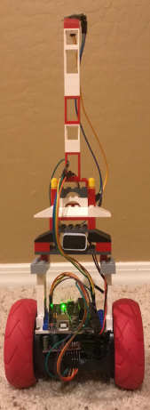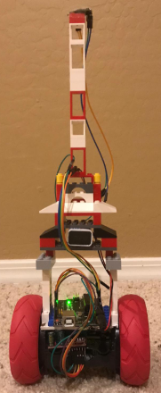

# Introduction

The purpose of this report is to do the testing for the design project. The team project is to implement any robot which fulfill the RoboGames rule and the team has decided to develop a balancing robot which can balance itself on all type of terrains and it will not fall down. The team has decided to build a robot with two wheelers with the accelerometer, gyroscope, and sonars to detect the hurdles. The robot is showing in the following figure.

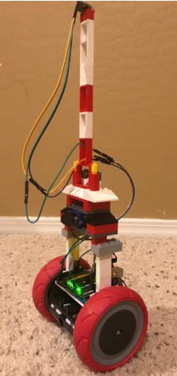

Figure 1: Balancing Robot

The robot has built now and it is in working condition, therefore it has taken for the test in open ground. The testing has done to see the several aspects of project which are engineering requirements, it has tested to see the engineering requirements have met or not. Following are the updated engineering requirements for this project.

Table 1: Engineering Requirements

|  |  |
| --- | --- |
| Engineering Requirements | Operational Values |
| Dimension | Less than 120 cm^2 |
| Battery Time | 15 minutes |
| Moving Capacity in the Arena | 50 meters |
| Height | 20 cm |
| Wheel Radius | 4 cm |
| Degree of Freedom | 2 Degrees |
| Width | 6 cm |
| Weight | 6 lb. |

# Battery Time

The battery has installed in the lower ground of the device as shown below

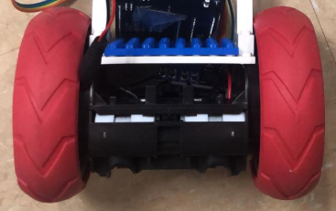

Figure 2: Battery

It has tested physically the battery timing of the device and has seen that it working more than for 15 minutes for sure. We have used the 20 mAh of four batteries

$$Battery =20 mAh$$

$$Total Batteries =20 mAh*4$$

$$Total batteries =80 mAh$$

And the consumption of the robot was near to 100 mA.

$$Robot Current=100 mA$$

Battery time has calculated as

$$Timing of Batteries=\frac{Battery capacity}{Current}$$

$$Timing of Batteries=\frac{80}{100}*60$$

$$Timing of Batteries=0.8* 60$$

$$Timing of Batteries=48 minutes$$

The device was working for more than 15 minutes easily and it has seen that the robot was moving for even more than 1 hour without any charging because the consumption was lower than 100 mA that’s why it was draining less amount of current. Hence this engineering requirement has fulfilled.

# Moving Capacity

The motors have installed in the lower ground portion of the device

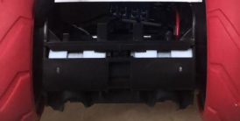

Figure 3: Motors

The motor used in the device are producing high torque, and they have high speed as well, the revolution per minute of the motors are

$$RPM=255 rpm$$

Using the above RPM the speed of the robot can be quite high but as the size of wheels are bigger than the size of motor so the RPM reduces for the robot. The size of motor rotor is around 10 times lesser than size of wheel so

$$RPM of Wheel=\frac{255}{10}$$

$$RPM of Wheel=25.5 rpm$$

And the maximum speed it can gain is

$$Circumference=2*pi*r$$

$$r=4 cm$$

$$Circumference=2*pi*4$$

$$C=25.13 cm$$

$$Maximum speed=C*RPM$$

$$Maximum speed=25.13*25.5$$

$$Maximum speed=640.88\frac{cm}{m}$$

$$Maximum speed=6.48\frac{m}{min}$$

$$Maximum speed=0.108\frac{m}{s}$$

Now calculate the distance it can travel in 15 minutes using the above speed

$$Speed =0.1\frac{m}{s}$$

$$Time =15 min$$

Time in seconds from minutes

$$Time =15*60$$

$$Time =900 sec$$

Distance covered

$$Distance=speed*time$$

$$Distance=0.1*900$$

$$Distance=90 meters$$

So the robot can easily travel for 90 meters in 15 minutes while the requirement is of 50 meters, hence this engineering requirement has fulfilled as well during the testing and it has tested that around 75 meters have covered easily in 15 minutes.

After the testing of the product it has then tested to see the engineering requirement of dimensions and sizes have met or not.

# Dimension

Dimension measured are

$$Width=7 cm$$

$$Height=17 cm$$

And the area calculated as

$$Area=widht*height$$

$$Area=7*17$$

$$Area=119 cm^{2}$$

The engineering requirements have met for the area and height, but the width of the device is little out, the requirement has stated to use 6 cm, while it is 7 cm, so its 1 cm more, but using the tolerance value of 1 cm, it becomes 7 cm as well. So it can count also that engineering requirement of width has met. The radius of the wheel has measured and it has found that wheel of the radius is

$$Radius=3.98 cm$$

Hence this engineering requirement has met as well. And then weight calculated using the weight machine and found that

$$Weight=5.34 lb$$

Hence the engineering requirement for the weight has met as well.

# Conclusion

The purpose of this report was to do the testing and it has tested and seen that robot is working perfectly fine in all the directions and it can balance itself on rough terrains as well. Further, all the engineering requirements have tested and found that all the requirements have fulfilled by the design.